**Full Metal Library Security Document**

**SD6503 Testing and Secure Coding Final Project**

Dave Sushames, Sachith Samarasinghe, Shontelle Steeg

Table of Contents

Security Document 3

A07:2021 Identification and Authentication Failures 3

What was done to fix it: 3

Secure coding practices used: 3

AO3:2021: Injection 4

What was done to fix it: 4

Secure coding practices used: 4

A01:2021: Broken Access Control 5

What was done to fix it: 5

Secure coding practices used: 5

Puma Scan 6

Figure 1: PasswordHelper on FullMetalLibrary. 3

Figure 2: Admin model with validation on FullMetalLibrary. 4

Figure 3: Author model with validation on FullMetalLibrary. 4

Figure 4: AuthFilter on FullMetalLibrary. 5

Figure 5: Puma Scan Results on FullMetalLibrary. 6

# Security Document

## A07:2021 Identification and Authentication Failures

Identification and Authentication Failures has been identified as a risk to our project, if our database stored plaintext passwords or had weak hashes it leaves it vulnerable to an attack. This can be exploited by an authorised user, it can allow them to gain access through logging in as an admin. The session could be hijacked if it is not managed securely. The apps sessions may not expire or the log out feature might not actually clear the session correctly. This leaves a window for the attacker to exploit the vulnerability and reuse another users session.

### What was done to fix it:

* We used a PasswordHelper class to hash the passwords. We used a hashing algorithm PBKDF2 with a random salt, so if an unknown user gained access to the system, the passwords are not recoverable.
* Sessions have also been protected with a 30-minute timeout and httpOnly cookies. which then means that no JavaScript can read them, or be reused.
* The Logout() method actually clears the session data instantly.

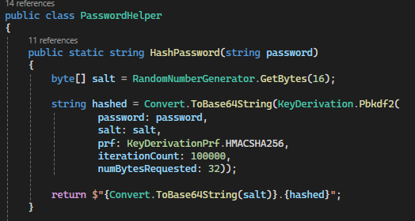

Figure : PasswordHelper on FullMetalLibrary.

### Secure coding practices used:

* Strong password hashing to protect the credentials stored.
* Secure session management to prevent any session attacks.
* Logout and timeout enforcement that will limit the time for an attack.

## AO3:2021: Injection

If user input is not validated it could lead to an SQL injection attack or Cross-site scripting when that input is being displayed. A threat actor could use this to read or modify sensitive information from the FullMetalLibrary app.

### What was done to fix it:

* The project was created using Entity Framework Core for the database, which automates parameterises queries.
* All models use validation attributes such as [Required] and [EmailAddress] that rejects unsafe or malformed data.
* The razor views use automatic HTML encoding, which means that user input is not directly rendered to the page.

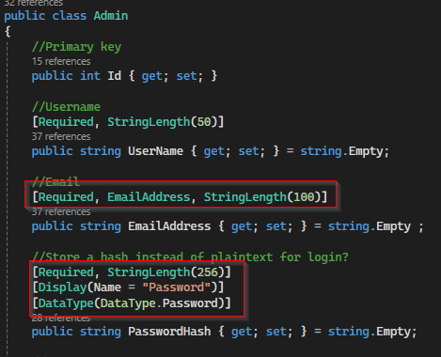

Figure : Admin model with validation on FullMetalLibrary.

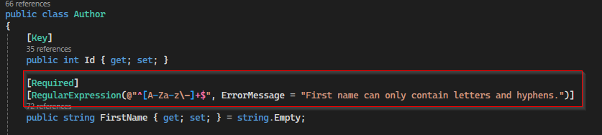

Figure : Author model with validation on FullMetalLibrary.

### Secure coding practices used:

* Entity Framework parameterisation to remove the threat of SQL injection.
* Validation attributes to block unsafe data before it can be saved.
* Razor auto HTML encoding to prevent XSS by default.

## A01:2021: Broken Access Control

If the routes or resources from FullMetalLibrary are not properly restricted, an unauthorised user could access the admin pages or perform actions that they should not be able to do.

### What was done to fix it:

To address this risk, the project uses a AuthFilter to protect all restricted routes. Before someone can execute a controller action, the filter checks if the current session has an active admin user. If they do not, it then redirects straight to the login page which then prevents any unauthorised access.

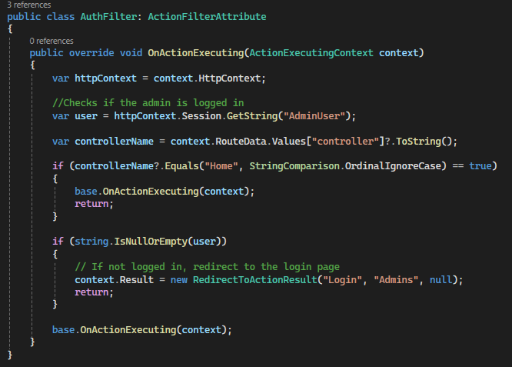

Figure : AuthFilter on FullMetalLibrary.

### Secure coding practices used:

* Access control enforced at the controller.
* Session based authentication checks before it loads a sensitive page.
* Default redirect to Login if the user has not been authenticated.

## Puma Scan

Figure : Puma Scan Results on FullMetalLibrary.

[IDE0290: Use primary constructor - .NET | Microsoft Learn](https://learn.microsoft.com/en-us/dotnet/fundamentals/code-analysis/style-rules/ide0290)

[IDE0090: Simplify 'new' expression - .NET | Microsoft Learn](https://learn.microsoft.com/en-us/dotnet/fundamentals/code-analysis/style-rules/ide0090)

[CA1859: Use concrete types when possible for improved performance - .NET | Microsoft Learn](https://learn.microsoft.com/en-us/dotnet/fundamentals/code-analysis/quality-rules/ca1859)

[IDE0028: Use collection initializers or expressions - .NET | Microsoft Learn](https://learn.microsoft.com/en-us/dotnet/fundamentals/code-analysis/style-rules/ide0028)

[CA1050: Declare types in namespaces (code analysis) - .NET | Microsoft Learn](https://learn.microsoft.com/en-us/dotnet/fundamentals/code-analysis/quality-rules/ca1050)

[CA1822: Mark members as static (code analysis) - .NET | Microsoft Learn](https://learn.microsoft.com/en-us/dotnet/fundamentals/code-analysis/quality-rules/ca1822)

[IDE0130: Namespace does not match folder structure - .NET | Microsoft Learn](https://learn.microsoft.com/en-us/dotnet/fundamentals/code-analysis/style-rules/ide0130)

[IDE0060: Remove unused parameter - .NET | Microsoft Learn](https://learn.microsoft.com/en-us/dotnet/fundamentals/code-analysis/style-rules/ide0060)

[SYSLIB diagnostics for regex source generation - .NET | Microsoft Learn](https://learn.microsoft.com/en-us/dotnet/fundamentals/syslib-diagnostics/syslib1040-1049)

[IDE0290: Use primary constructor - .NET | Microsoft Learn](https://learn.microsoft.com/en-us/dotnet/fundamentals/code-analysis/style-rules/ide0290)